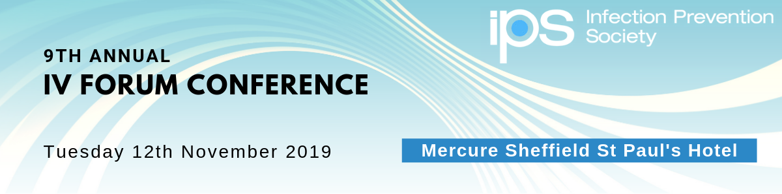
The Infection Prevention Society (IPS) IV Forum Special Interest Group would like to invite you to attend their annual conference with the theme of 'Poison IVY - Reducing the Risks of IV Therapy' on Tuesday 12th November at Mercure Sheffield St Paul’s Hotel & Spa in Sheffield. The first 80 IPS members attend free of charge. All other members and non-members pay £45 to attend.
This day will be of interest to all healthcare workers including infection prevention and control practitioners, matrons/team leaders, IV nurse specialists, Vascular teams, OPAT teams, Critical care nurses, Microbiologists, Anaesthetists and anyone with an interest in vascular access and current infection prevention practices in IV.
Programme Highlights
- DRIPP: (Device related infection prevention practice) Collaboration
- IPS IV Projects Update – Frameworks and Passports: Dr Tim Jackson and Valya Weston
- IV Therapy and Devices – an update of National and International Advances: Jackie Nicholson
- IV Medications – Accessing Guidance and Reducing the Risks: Susan Keeling
- Emerging Roles in Vascular Access: Alex Villaplaza
- Antimicrobial Therapy going forward – What the Future Holds: Katherine Ajdukiewicz
- Reducing the Silos – Benchmarking IV Services: Sue Rowlands

As well as a varied programme there will be an exhibition with a wide variety of companies for you to visit and hear about new and innovative products to the market. During the refreshment breaks is an ideal opportunity for you to socialise with like-minded colleagues and discuss the issues you face on a daily basis.
If you are on Twitter, please tweet about the event using #IPSIV19 and follow @IPS_Infection for more information.
For more information and to register visit https://www.ips.uk.net/event/ips-iv-forum-2019/

