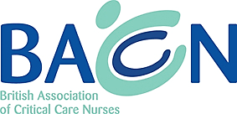

Southern Region Event

Support and Sustain

A review of critical care pandemic experiences and reflections on supporting critical care into the future

Thursday 25 February 2021
17:30-21:00
Governors Hall
St Thomas’ Hospital London

BACCN Members £25 Non-members £30 – includes light meal

Book online https://www.baccn.org/regions/southern/southern-events/

